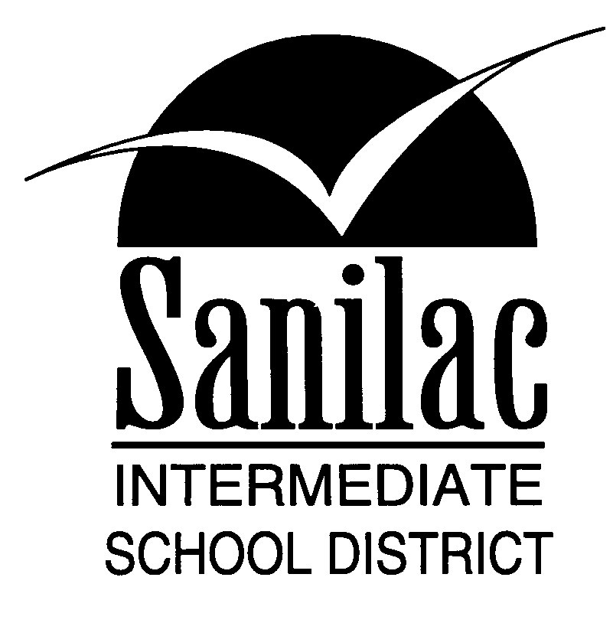
Special Education Services
46 North Jackson Street
Sandusky, Michigan 48471
810-648-2200

MEDICAL REPORT FOR

THREE YEAR RE-EVALUATION

Brown City Community Schools Deckerville Community Schools Sandusky Community Schools

810-346-2781 810-376-3615 810-648-5225

Carsonville/Pt Sanilac Schools Marlette Community Schools Sanilac ISD Special Education

810-657-9393 989-635-4921 810-648-9020

Croswell/Lexington Community Peck Community Schools
810-679-1445 810-378-5200

NAME: __________________________________________ BIRTH DATE: __________________

ADDRESS: _______________________________________________________________________

STREET/P.O. BOX CITY ZIP
PARENT’S NAME: ___________________________________ PHONE: ____________________
NAME OF SCHOOL: _________________________________ TEACHER:__________________
GRADE: _______________________________ REFERRED BY: __________________________
STUDENT’S MEDICAL DIAGNOSIS:
____________________________________________________________________________________________________________________________________________________________________________________________________________________________________________________________________________________________________________________________________

TEMPORARY CONDITION PERMANENT CONDITION
SIGNATURE: ______________________________________ DATE: _______________________

